## Member: Pham Tuan Kiet, Trinh Huynh Duc

## User: Admin

Goal: Admin can create accounts to access to the system and managing the closure date for the articles.

Triggers: User login using the admin account

Preconditions: Admin account must exist in the database and accessible.

## Test case:

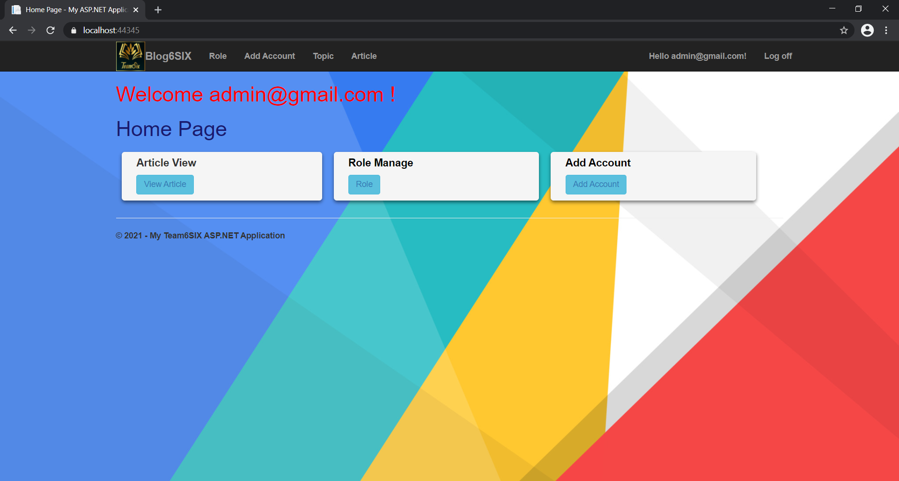

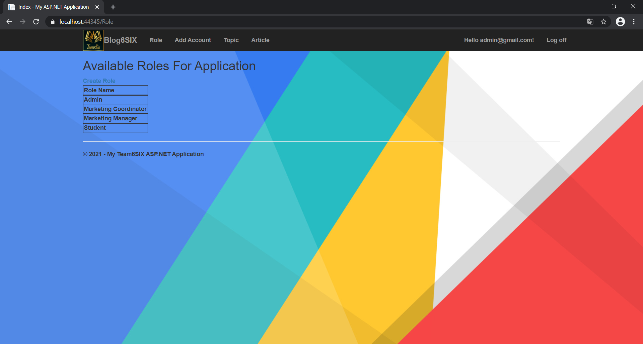

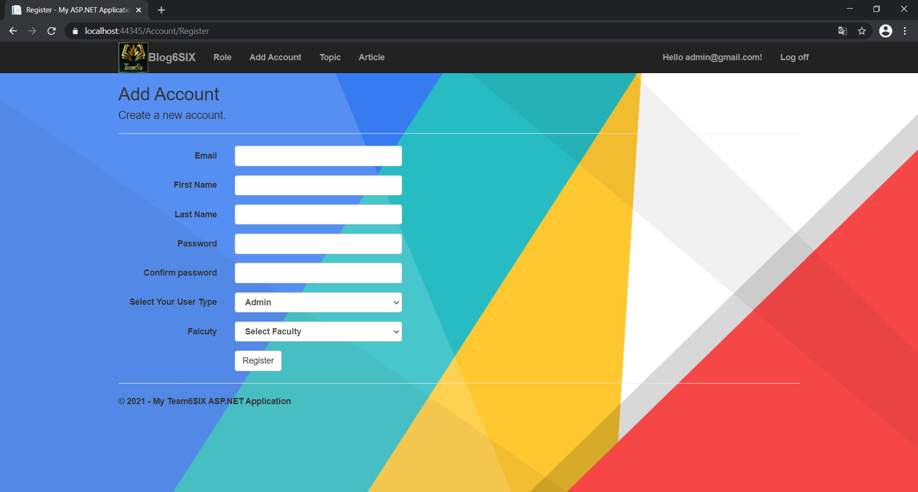

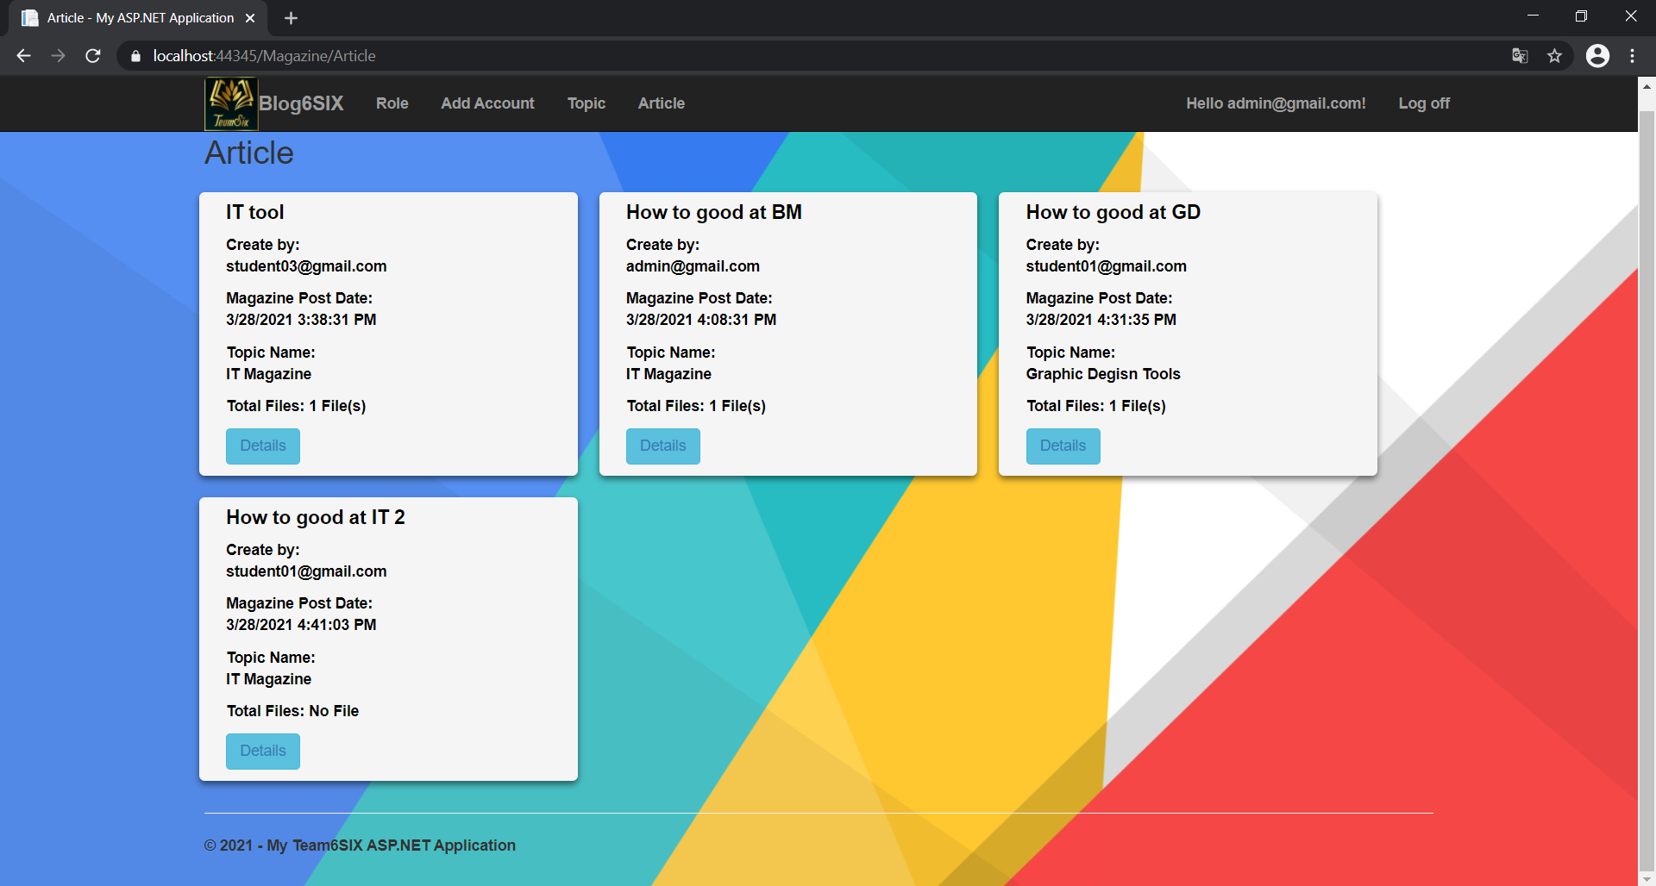

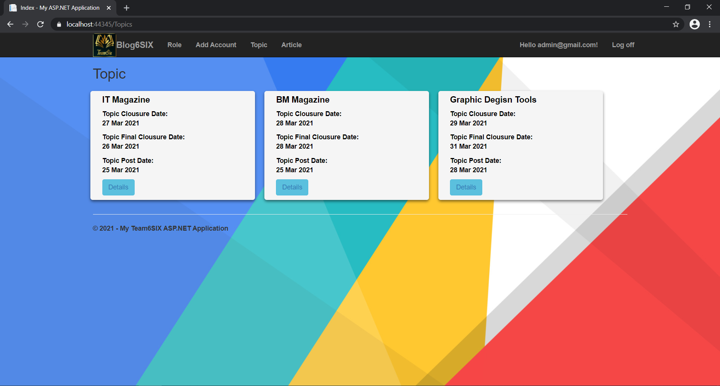

|  |  |  |  |  |  |
| --- | --- | --- | --- | --- | --- |
| **Functions** | **Test Scenario** | **Step Description** | **Expected Result** | **Actual Result** | **Status** |
| Test if admin can set the closure date for each faculty | Admin can set the closure date | 1) Login using an Admin account 2) Select closure date and set date | The closure date should be set successfully | Successful | Pass |
| Test if admin can set the closure date before today | Admin setting the closure date | 1) Login using an Admin account 2) Select closure date and set a date before the current's testing date | The system should make report an appropriate error | Nothing | Fail |
| Test if closure date is available when creating an article | Student can see the closure date | 1) Login using a Student account 2) Create a new article | The closure date should be seen in the creating process | Successful | Pass |
| Test if student can upload articles after the closure date | Student cannot upload after the closure date | 1) Login using a Student account 2) Create a new article after a closure date | The system should make report an appropriate error | Nothing | Fail |